Technical Report

Collate My Social Feed – Team unified

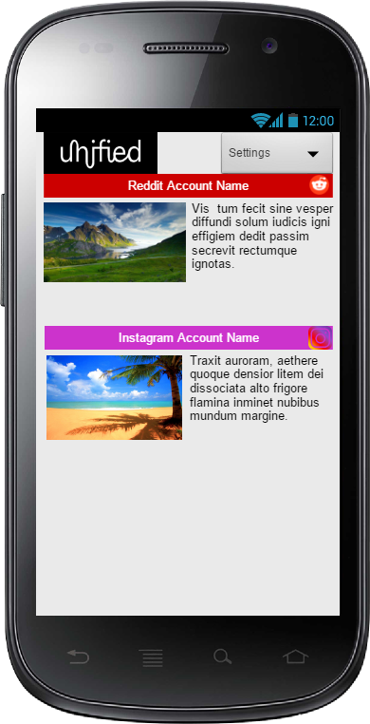

Zain Iftikhar, Kasim Hussain, Tiffany Hobbs, Dominik Jadczak, Keir Storm J Fowler

Contents

Introduction 2

Design 3

Implementation 4

User Guide 5

Conclusion 6

Bibliography 7

# Introduction

This project consists of an Application that integrates a user’s various social media platforms into one, such that they can view all their social media platforms in that one App rather than logging into all the different platforms individually. The main objective is to make it a hybrid-native mobile Application that fetches a user’s social media entry from multiple supported networks and display them in a unified feed. The user should be able to connect/authenticate multiple accounts from each platform supported and view their feed chronologically in a standardized format. By default, the App should display text along with an image; however, the user should be able to refine their experience. They should be able to:

* Select between the different networks shown in the feed.
* Search for a keyword to base the content of the feed (Reddit).
* Specify a time- period from which posts are viewed.
* Finally, the user should be able to click each post and it should open within the web browser on the social network site allowing for commenting, liking and sharing. (All this is done within the networks own login etc., we do not provide anything but the link for a user to visit and then authenticate with).
* Show all related ads for a specific user account (when using multiple accounts from the same network).
* Have a Light and Dark mode theme for browsing at any time of the day.

To achieve all this, we must build plugin functionality for one social media network and build on that to add any additional enhancements/ features. Research plays a big art in this. The Application used to build this will be visual studio, in conjunction with Ionic and Cordova framework that is running off AngularJS.

Cordova provides access to native app plugins that can be called and communicated with a simple JavaScript call; they are installed via Node Package Manager and then linked into the app.js file. Ionic is a framework that provides styles and features (kind of like bootstrap), further enhancing the user experience and the user interface.

Building the app is very simple you specify a platform, which you wish to build, it fetches the required files and then outputs a project that is of that which you specified. IOS can only be ran on macOS based machine whereas Android can be run on either. Tests are run on the Emulators and via real hardware devices to make sure; everything runs the same as found in the Emulator.

# Design

The design is a key feature in order to attract someone to use it. A simple light or dark theme should do the trick. The design of the Application can be created using the Ionic framework in order to enhance user experience. However, before the main design of the App is created a draft must be drawn up. This is so that you can plan what it will look like. Wireframes are a good way to this. This provides an overall experience of how the app will feel without having to code anything. So by creating multiple wireframes with various, design will help decide a winner so that you can begin actually coding the main App design. Various components will need to be taken into consideration with designs, such as:

* How the data is shown in the main feed.
* How the display of the setting page will look like.
* What the main theme of the App will be (either light or dark but kept consistent).
* How the user will be able to refresh the page. (Refresh button or a pull-down refresh gesture).

# Implementation

This will take a huge chunk of time, as these are the main stages of piecing together the mobile Application. The features that are implemented in this stage are as follows;

1. Home screen/ feed view:
   1. Theme: a theme will need to be decided for the home screen view. This can be achieved via ionic framework. A simple light or dark theme should suffice.
   2. Layout: As previously mentioned, wireframes are a good way to make a proto-type of how you want the layout of the App to look. An example of this could be; once the feed page loads it starts with and image of the related search and a small text description under the image of the post. Also, within the text should be a hyperlink that takes the user to a web view of the feed
   3. Search bar: Like most default Apps, a search is necessary. This should allow the user to refine parameters. This can be created by using HTML input tags.
2. Settings page
   1. Theme: a theme will need to be decided for the home screen view. This can be achieved via ionic framework. A simple light or dark theme should suffice.
   2. View: this should allow the user to add accounts, delete accounts, view posts by date posted.it should allow the user to add or hide posts. There should also be a cog icon in the feed page allowing the user to click and bring them to the setting page. This can be done by implementing JavaScript and HTML.
   3. View: this should allow the user to add accounts, delete accounts, view posts by date posted.it should allow the user to add or hide posts. There should also be a cog icon in the feed page allowing the user to click and bring them to the setting page. This can be done by implementing JavaScript and HTML.

# User Guide

When your app opens for the first time you will be taken to the landing page this will tell you that your feed is empty and that you need to connect your account to do this click on the message to connect your account. This will then take you to the add accounts page where you can choose between different platforms you would like to add to your feed. To add an account, click on the logo of the social media platform you would like to add which will take you to the account authentication where you have a choice to click ok or cancel.

If you have made any mistakes by clicking cancel it will take you back to the previous page and by clicking ok will allow you to let the app access your social media feed. You will then be taken to your feed page where you are able to view your social media feed chronologically in a standardized format and be able to click on any posts which will open a web browser on the social media site allowing for commenting, liking and sharing posts. Also, on the feed page you have a settings button by clicking this it will take you to the settings page here you are able to search you feed for specific information by clicking the search bar and typing a keyword e.g. Football this will then display all the information with the keyword football.

On the settings page you have a choice to switch the colour theme by choosing either light or dark mode to change the theme just click on the theme button. You also have the choice to specify if you want to view text and or media on your feed by ticking which content you would like to see. If you are looking for posts between a specific date e.g. 1st April 2012 you can click the text “From” that will take you to the timeline page where you can change the date to look for posts in the past. Underneath that there is a menu that allows you to select your feed type this allows you to change your feed to just friends, adverts or even customise it.

If you would like to view multiple accounts of the same social media, you can click on select accounts this will come up with a list of the accounts you have authorised and can tick which accounts you would like to view on your feed. We also have a button that allows you to report any problems to our team. To add or remove an account we have a button at the bottom of our settings page by clicking on it will take you through the add or remove account page and follow the steps.

# Conclusion

Social media is very popular amongst the world people spend so much time switching between social media apps, almost everybody has at least one or more with many to choose from such as Facebook, Twitter, Instagram these are just a few of the options. This app allows users to view all of these feeds into one app instead of switching between different applications or websites individually. Collate My Social feed will display text along with an image however users will be able to refine their experience by displaying specific information by using the search bar that will use keywords to base the content of the feed. Also this app will allow a user to specify a time period from which posts are viewed. Other features will allow you to choose to view multiple accounts on the same platform and even switch between a light and dark theme.

# Bibliography

Digilabs, A. (2017). *The Urban Wild*. [online] Trello.com. Available at: https://trello.com/b/NE72yJ87/userstories [Accessed 19 Nov. 2018].

Digilabs, A. (2018). *Supporting live projects*. [online] GitHub. Available at: https://github.com/AliceDigitalLabs/SupportingLiveProjects_2018/wiki [Accessed 19 Nov. 2018].

Ionic Framework (2019). *Getting Started with Ionic - Ionic Framework*. [online] Ionicframework.com. Available at: https://ionicframework.com/docs/v1/getting-started/ [Accessed 20 Nov. 2018].

Raboy, N. (2014). *ng-cordova-oauth*. [online] GitHub. Available at: https://github.com/nraboy/ng-cordova-oauth [Accessed 19 Nov. 2018].

Raboy, N. (2019). *Using An Oauth 2.0 Service With Ionic Framework*. [online] The Polyglot Developer. Available at: https://www.thepolyglotdeveloper.com/2014/07/using-oauth-2-0-service-ionicframework/ [Accessed 20 Nov. 2018].